KATHMANDU UNIVERSITY

School Of Engineering

Department Of Mechanical Engineering

Progress report on



“COMPARISON OF THRUST TO WEIGHT RATIO OF AEROSPIKE NOZZLE WITH CD NOZZLE”

In Partial Fulfillment of the Requirements for the Bachelor’s Degree in Mechanical Engineering

**SUNIL BELBASE (31088)**

**AAKASH MALI (31103)**

**SUJIT MAN SHRESTHA (31113)**

**AUTHORIZATION**

We hereby declare that we are the author of the project.

We authorize Kathmandu University to lend this thesis to other institutions or individuals for the purpose of scholarly research. We further authorize Kathmandu University to reproduce the thesis by photocopying or by other means, in total or in part, at the request of other institutions or individuals for the purpose of scholarly research.

|  |
| --- |
| **SUNIL BELBASE _______** |
| **AAKASH MALI _______** |
| **SUJIT MAN SHRESTHA _______** |
|  |
|  |

03 May, 2022

**PROJECT EVALUATION**

COMPARISON OF THRUST TO WEIGHT RATIO OF AEROSPIKE NOZZLE WITH CD NOZZLE

By

SUNIL BELBASE

AAKASH MALI

SUJIT MAN SHRESTHA

This is to certify that I have examined the above and have found that it is complete and satisfactory in all respects, and that any and all revisions required by the thesis examination committee have been made.

Dr. SAILESH CHITRAKAR

Dr. SURENDRA SUJAKHU

Assistant professor

(Project Co-Ordinator)

Kathmandu University

Assistant Professor

(Project Supervisor)

Kathmandu University

April, 2022

**AKNOWLEDGEMENT**

We would like to thank everyone who has helped us conducting this project. We would like to express our special thanks of gratitude to our project supervisor DR. **SAILESH CHITRAKAR**, who has supervised us throughout the project. His help, suggestions, support and encouragement, helped us to a lot of background study of the project. Many thanks to Department of Mechanical Engineering, **KATHMANDU UNIVERSITY** for providing us the golden opportunity to do this project. And we would like to thank those people who gave their helping hands directly or indirectly for this project.

Our special thanks go to countless readers of this project report who provide us with important comments and further suggestions to improve our existing project. We welcome constructive comments and suggestions which will help us to do better in future.

It is our radiant sentiment to place on record our kindest regards to whoever were directly and/or indirectly involved in the successful completion of this project

**ABSTRACT**

Aerospike nozzle is a preferable alternative nozzle system being considered for its prominent features and altitude compensating features. Among rockets with bell shaped nozzles, a significant amount of energy and potential momentum is wasted as a result of sideways component losses. Aerospike nozzles resolve those problems faced in conventional converging diverging (CD) nozzles, completely eliminating the need of moving parts or multi stage propulsion systems otherwise employed to maintain a steady thrust with varying altitude. The prime objective of this research is to compare the differences in thrust between aerospike nozzle and CD nozzle. This is achieved through a) flow simulation of exhaust using ANSYS 2021 in first phase and b) real time data collection from an actual scaled down propulsion system in second phase. Data from both the methods is then compared for further analysis to conclude the efficiency of nozzles under ambient pressure.

***Keywords: Aerospike, CD, nozzle, Thrust, Pressure Chamber, Altitude compensation***

Contents

CHAPTER 1: INTRODUCTION 9

BACKGROUND 9

DISCUSSION 9

CHAPTER 2: METHODOLOGY 12

2.1 THEORETICAL FRAMEWORK 12

2.2 MATHEMATICAL MODELLING OF HEAT FLOW THROGH THE WALL 14

2.3 SIMULATION ON ANSYS 16

2.3.1 MESH GENERATION 16

2.3.2 CFD SETUP AND SOLUTION 16

2.3.3 SIMULATION OF TEMPERATURE DISTRIBUTION 18

2.3.4 SIMULATION OF HEAT FLUX USING ANSYS 20

2.3.5 PRESSURE DISTRIBUTION 21

2.3.6 MACH NUMBER DISTRIBUTION 22

2.3.7 VELOCITY CONTOUR 23

CHAPTER 3: DESIGN OF NOZZLE 24

3.1 DESIGN OF BELL-SHAPED CD NOZZLE 24

3.2 DESIGN OF CONICAL SHAPED CD NOZZLE 24

3.3 DESIGN OF AN AEROSPIKE NOZZLE 25

CHAPTER 4: PROPULSION EXPERIMENTATION 27

4.1 SOLID PROPELLANT 27

4.2 PRESSURE VESSEL / COMBUSTION CHMABER 27

4.3 TEST RIG 27

4.4 SENSORS AND ELECTRONICS 28

CHAPTER 5: FUTURE OF THE PROJECT 29

5.1 GANTT CHART FOR FIRST SEMESTER 29

5.2 WORK UNEXPENDED 30

CHAPTER 4: CONCLUSION 31

GLOSSARY 32

REFERENCES 33

Table of Figures

Figure 1: Converging Diverging Nozzle configuration where red indicates higher velocity 10

Figure 2: Exhaust contour for aerospike nozzle where red indicates velocity with Mach number equal or greater than 1 11

Figure 3 Aerospike nozzle 11

Figure 4:Mesh generation on control volume 17

Figure 5: Distance of cowl vs temperature distribution graph 19

Figure 6: Contour of heat flux 20

Figure 7:Exhaust pressure distribution on a CV 21

Figure 8:Mach no. distribution of exhaust gases on a control volume 22

Figure 9: Velocity contour of exhaust gases in control volume 23

Figure 10: Schematic representation of a bell nozzle 24

Figure 11: Schematic diagram of conical shaped CD nozzle created in SOLIDWORKS 25

Figure 12: Dimensions for a converging-diverging nozzle 25

Figure 13: Bottom view of an aerospike nozzle. Blue portion represents cross section of spike and white portion represents exit area 26

Figure 14:Representation of an aerospike nozzle 26

Figure 15: Test Rig that houses and immobilizes the nozzle. This drawing was made using SOLIDWORKS 28

Figure 16: Sensors and necessary electronics used for experimentation 28

ABBREVIATIONS

CD Converging Diverging

CAD Computer Aided Drawing

CFD Computational Fluid Dynamics

M Mach no.

Po Atmospheric pressure

P Pressure

Pe Pressure at exit

T Temperature

Ve Velocity at exit

Vt Velocity at throat

A Cross sectional Area

Th Thrust

# CHAPTER 1: INTRODUCTION

## BACKGROUND

Ever since jet and rocket propulsion systems have emerged, researchers have invented and implemented many types of nozzles, mainly to increase the thrust performance of nozzles in off-design working conditions. Among these various designs, features of the aerospike nozzle have attracted researchers since mid-1950s. Many theoretical studies of the aerospike nozzle have been carried out in 1960s. In early 1970s, thermal and strength problems of the aerospike nozzle and development of more efficient methods for fabrication of conventional nozzles led to a decline in research activities in this field. Development of the nozzle with the capability of producing optimum amounts of thrust in wide ranges of altitude has been a subject of continuous dedicated efforts within the community of rocket propulsion. The phenomenon of producing optimum amounts of thrust by a rocket nozzle in off-design conditions is called as *altitude compensation*. Nozzles with the altitude compensation characteristics are basic feature in realizing the development of Single Stage to Orbit (SSTO) vehicles. Reusable SSTO vehicles offer the promise of reduced launch expenses by eliminating recurring costs associated with hardware replacement inherent in expendable launch systems. The most popular altitude compensating rocket nozzle to date is the aerospike nozzle, the origin of which dates back to Rocketdyne in 1950s. [Mohammad Imran]

## DISCUSSION

The prime reason for switching a conventional CD nozzle is because of its inability to compensate for varying altitude in single stage orbit launches. Ambient pressure around the nozzles is the function of altitude. Increasing altitude causes the ambient pressure to decrease that creates pressure drag for high-speed exhausts. Exhaust gases tend to *under expand* over low ambient pressure at higher altitudes and *over expand* over higher ambient pressure at lower altitudes. This imperfect expansion of gases cause vector losses by deviating the vertical momentum.

* **Conventional Diverging Nozzle**: Conventional Diverging nozzle or Converging-Diverging nozzle is a simple nozzle with small cross-section at subsonic flow of exhaust and larger cross section at the supersonic flow. Upper part where fluid compresses and creates high pressure is called the converging part whereas the lower part where fluid gains velocity at the expense of pressure is called as the diverging part as shown in figure 1. The thrust of rocket can often be described with the function of expansion ratio and pressure ratio, where expansion ratio is the ratio of diameter of throat of nozzle to diameter of exit[**3**].

Ft = Me. Ve + (Pe-Po) ×At--------------------------------------(1)

: Exit Mach no.

Po:  Atmospheric pressure

Pe: Pressure at exit

Ve: Velocity at exit

: Cross sectional throat Area

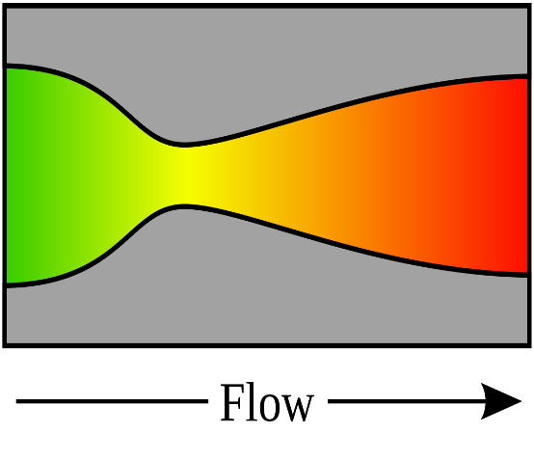

Source: K Naveen Kumar et al 2017 IOP Conf. Ser.: Mater. Sci. Eng. 247

Figure 1: Converging Diverging Nozzle configuration where red indicates higher velocity

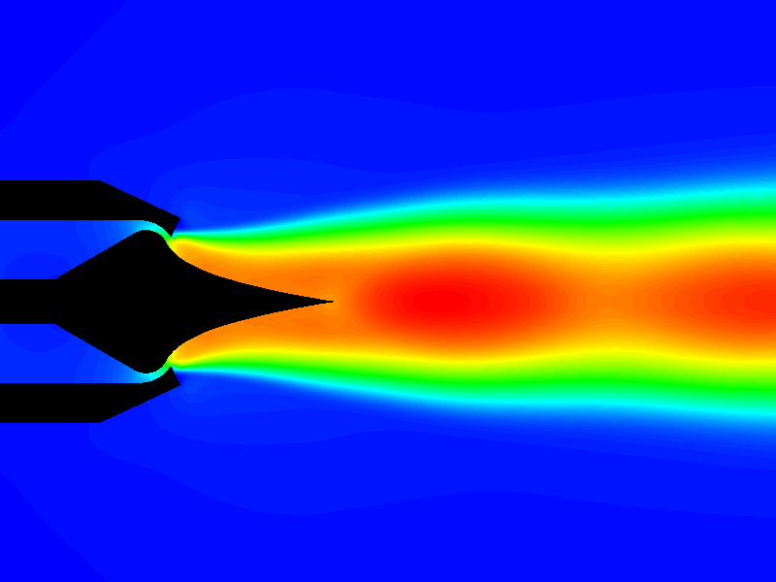

* **Aerospike Nozzle:** Aerospike nozzle is an ingeniously designed nozzle for propulsion system alternative of adoption for outside pressure variations. The concept has been under development since 1950s. Aerospike counters to solve the problem faced in conventional nozzles without the need of moving parts. Conventional converging diverging (CD) nozzle trades off performance for altitude. The key feature of the aerospike engine is that, as the launch vehicle ascends during its trajectory, the decreasing ambient pressure allows the effective nozzle area ratio of the engine to increase.

Figure 2: Exhaust contour for aerospike nozzle where red indicates velocity with Mach number equal or greater than 1

Source: 2005 LANCEMORE company [online website]

Figure 3 Aerospike nozzle

An aerospike nozzle is often referred to as an altitude-compensating nozzle, because of its specific design capability of maintaining aerodynamic efficiency as altitude increases and thus throughout the entire trajectory. The aerospike features a series of small combustion chambers along the ramp that shoot hot gases along the ramp's outside surface to produce thrust in a spike-shaped plume, hence the name “aerospike” as shown in figure 2. The ramp serves as the inner wall of the bell nozzle, while atmospheric pressure serves as the "invisible" outer wall. The combustion gases race along the inner wall (the ramp) and the outer wall (atmospheric pressure) to produce the thrust force. The aerospike will not suffer from the same overexpansion losses a bell nozzle suffers and can operate near optimum capacity, giving the highest possible performance at every altitude up to its design altitude. Above the design altitude, the aerospike behaves much like a conventional bell nozzle.

# CHAPTER 2: METHODOLOGY

## 2.1 THEORETICAL FRAMEWORK

The major objective of this project is to obtain a comparative result regarding magnitude of thrust between Aerospike nozzle and CD nozzle. Propulsive force for a rocket is determined through thrust to weight ratio, which can simply be obtained after thrust is known. Thrust for nozzle wall contour is calculated by integrating nozzle wall pressure over the surface area projected in the axial direction.

Thrust (F) = P×A (1 + γ M2) cosα + P×A – cosα------------------------------(i)

Where, γ = Ratio of specific heats

α = Thruster angle with respect to horizontal axis

Equation (i) can further be simplified and written in terms of Mach number, which is given by

Thrust (F) = Me×Ve + A× (Pe – Po) --------------------------------------------------------(ii)

Where, : Exit Mach no.

Po:  Atmospheric pressure

Pe: Pressure at exit

Ve: Velocity at exit

A: Cross sectional Area

Also, the ground works for thrust can be laid using Newton’s second law of motion as it defines force as rate of change of momentum

F = = v., where = mass flow rate through exit

For compressible gases, mass flow rate is given by

= × M--------------------------------------------(iii)

= × M -----------------------------------------(iv)

Equation (iv) indicates that mass flux for a nozzle is a function of Mach number.

The relation of Mach number and mass flux is against the proportionality between the parameters in equation (iv), such that, maximum mass flow rate for a nozzle is obtained whenever Me = 1 ideally. Any further increase in Mach number causes the exhaust flow to choke. *Choked flow* refers to flow when mass flow rate per unit area does not increase in further reduction in back pressure. [**4**]

## 2.2 MATHEMATICAL MODELLING OF HEAT FLOW THROGH THE WALL

Total power generated inside the cowl is given by Q

Q = =

=

= 126,984 J/s

A = Total area of heat dissipation = 0.0264 m2

K= Thermal coefficient = 36 J/mk for polished steel

It is necessary to get hold of necessary data that will be used all over the analysis. These data include temperatures that vary over the distance x from the inside wall, and is simply explained through temperature gradient . This, is achieved by modelling the system using quadratic differential equation given by FOURIER’S LAW [6].

AK. + Q = 0------------------------------------------------------------------(1)

or, 0.0264×36× + 126984 = 0

:. 0.954 + 126984 = 0

The trial function for a quadratic differential equation is

T = a1 + a2x + a3x2--------------------------------------------------------------------------(2)

Applying boundary condition, we have

When x = 0, T= 1473k

:. T= a1=1473k

When x= 0.005m, T= 1323k

T= 1473+ a2×0.005+a3(2.5×10-5)

)

:. T= 1473+ a2.x + (-6×106).x2

Differentiating twice with respect to x on both sides,

= -(12×106) – 400a2 ------------------------------------------------------------------(3)

Putting (3) equation (1), we get

a2 = -29,653.34

a3 = -69,332

-----------------------------------------------------------(4)

Hence, (4) defines the relationship between temperature T and distance x from internal wall of cowl.

From (4),

## 2.3 SIMULATION ON ANSYS

### 2.3.1 MESH GENERATION

The 3D structure of Aerospike nozzle requires intense thermal analysis on how heat flows, distributes and dissipates statically. But the thermodynamics of exhaust require analysis on other parameters such as velocity of exhaust before and after dissipation, pressure inside and outside the chamber, Mach number just inside and outside nozzle and thermal stress subjected to the material. All the parameters are either studied through tedious hand calculations or simulations. This report discusses on these parameters through simulation using ANSYS 2021. The 3D structure is projected to create a 2D model of same in order to make analysis less tedious by trading slight accuracy. This allows a control volume domain to exist on which Eulerian analysis is done.

### CFD SETUP AND SOLUTION

ANSYS Fluent Boundary Conditions used for simulations are given as below,

1. Solver = Density based
2. Space = Planer-2D
3. Viscous model = SST k-omega turbulence model
4. Operating Pressure = 0 pa
5. Domain = Fluid

Boundary Conditions

* Pressure Inlet

1. Gauge total pressure = 100kpa
2. Total temperature = 300k
3. Direction Specification = Normal to boundary

* Pressure Outlet

1. Gauge total pressure = 10325pa
2. Backflow total temperature = 300k



Figure 4:Mesh generation on control volume

Mesh generation on control volume (represented by green), where blue arrow indicates flow in and red arrow indicates flow out

### SIMULATION OF TEMPERATURE DISTRIBUTION

APDL setup for heat flow simulation is given below

1. Preferences = Thermal
2. Element Type 1 Plane55
3. Materials Model
   1. Conductivity(K) = 36.5 J/mk
4. Temperature
   1. Lower End(T1) = 1200
   2. Upper End(T2) = 1050

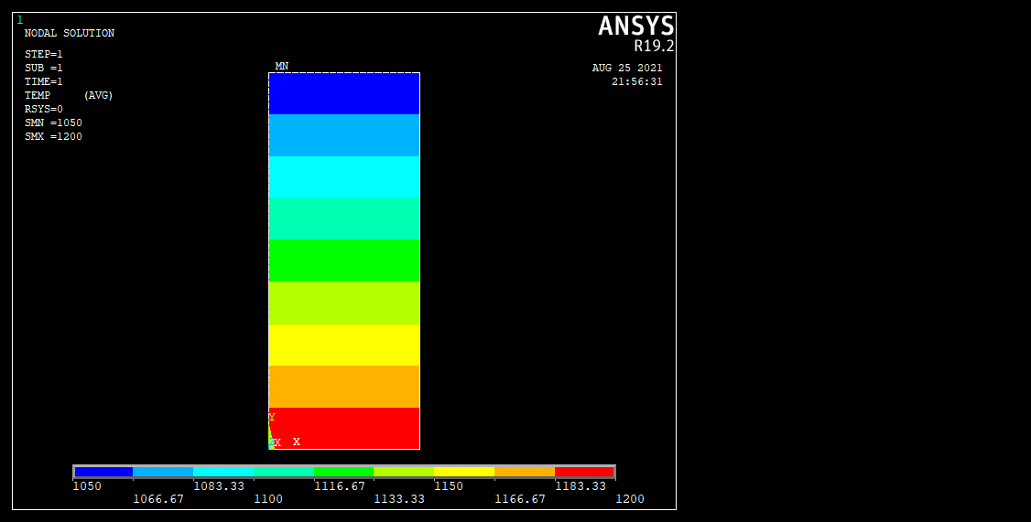The above calculated theoretical data were verified from ANSYS APDL after exposing the wall at seemingly similar environments and values such as that of K and A. Figure 3 represents the temperature counter spread over 5mm wall of the Aerospike nozzle with nine different levels of temperature exposures. Blue indicates the coolest temperature of 1050 degree Celsius whereas red indicates hottest exposure of 1200 degree Celsius.

Figure 3: Temperature counter over 0.005m wide cowl wall of aerospike nozzle

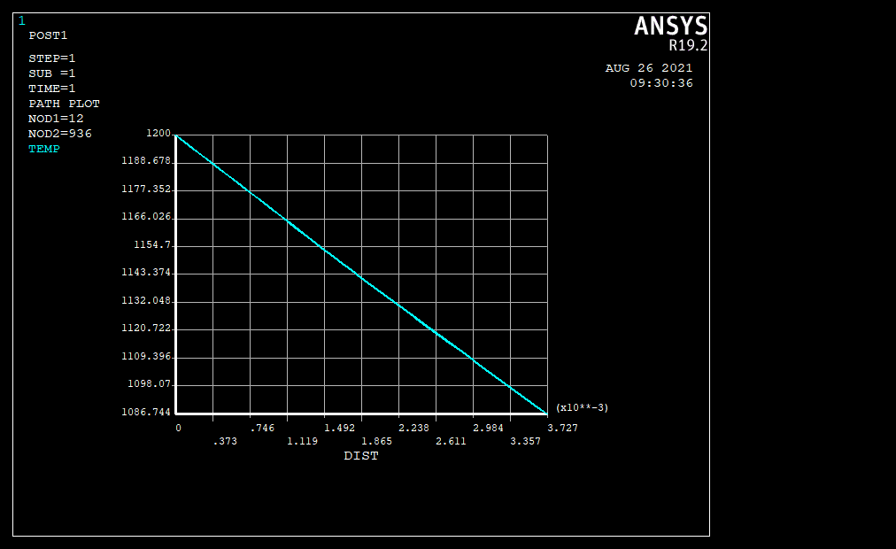

Figure 5: Distance of cowl vs temperature distribution graph

Though the representation seems linear, the plot is actually quadratic in nature that has been scaled down

### SIMULATION OF HEAT FLUX USING ANSYS

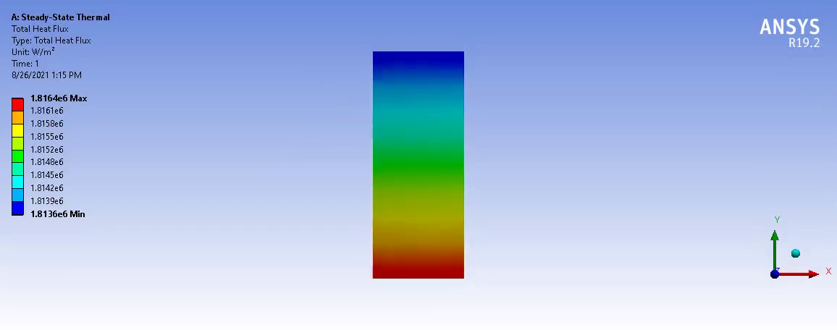Figure 5 represents heat flux input and heat flux output through each side of the wall of Aerospike nozzle. From previous data of temperature change along with distance from cowl, surface area and thermal heat coefficient, the heat flux has been simulated to be 1.81 MJ/m2s in and out, when exposed to ambient pressure.

Figure 6: Contour of heat flux

### PRESSURE DISTRIBUTION

The simulation shown by figure 7 represents how pressure is released through the nozzle. For any adiabatic nozzle, entirety of the pressure energy is converted to kinetic energy. This is also called pressure throttling. Inside the pressure chamber, pressure is created through combustion of solid fuel, and is allowed to release through constricted nozzle. Higher pressure in red zone is allowed to throttle into surrounding atmosphere through a constricted opening.

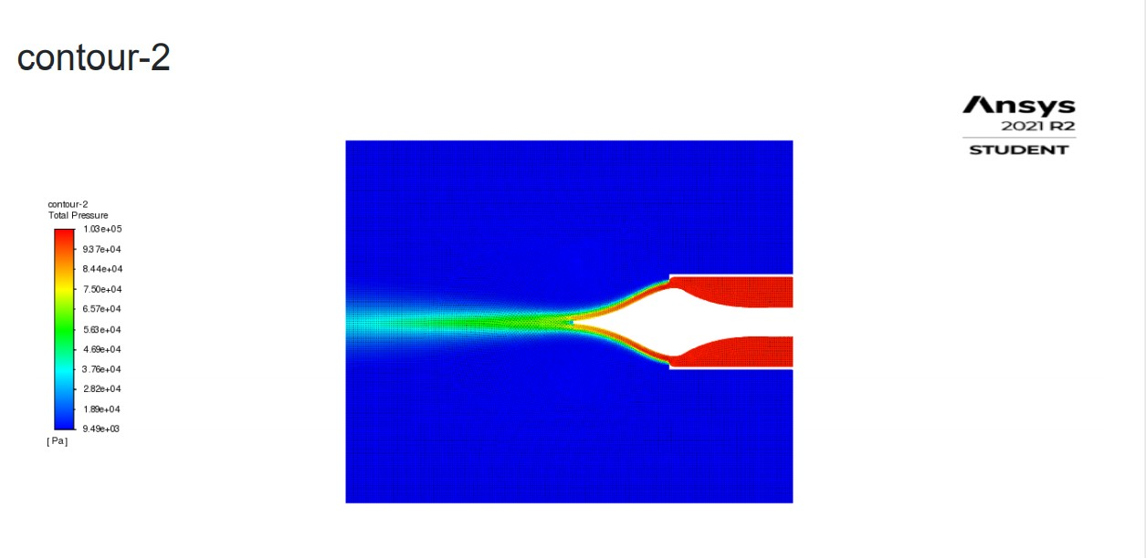

Figure 7:Exhaust pressure distribution on a CV

### MACH NUMBER DISTRIBUTION

Figure 8 shows the Mach number distribution for exhaust along the spike. Blue zone represents stationary vector contour and red represents fluid flow at Mach one concentrated around nozzle and along the spike.

Mach numbers play a vital role in determining the mass flow rate of exhaust gases. Increasing Mach numbers refer to increasing velocity, which therefore increases the mass flow rate. But, the relation of Mach number and mass flux is against the proportionality between the parameters such that, maximum mass flow rate for a nozzle is obtained whenever Me = 1 ideally. Any further increase in Mach number causes the exhaust flow to *choke*. This has also been simulated and shown below as conditions with ideal characteristics are applied.

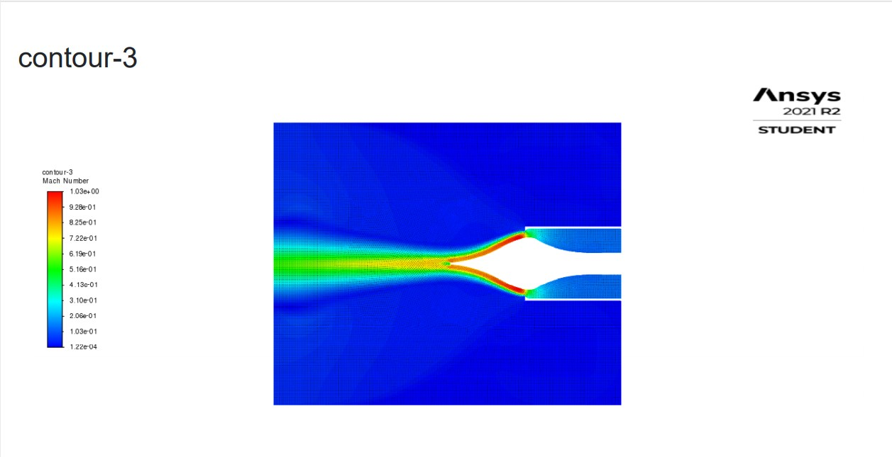

Figure 8:Mach no. distribution of exhaust gases on a control volume

### VELOCITY CONTOUR

Figure 9 represents velocity distribution of exhaust gases in a control volume. The velocity contour and Mach number contour have similar profiles as Mach number indirectly represents velocity.

The main purpose of any aerospike nozzle is to maintain a systematic and non-random exhaust flow and compensate the altitude. This is achieved by directing flow in a single direction and preventing sideways vector component losses. Simulation on ANSYS shows similar result as it is discussed, with minor losses.

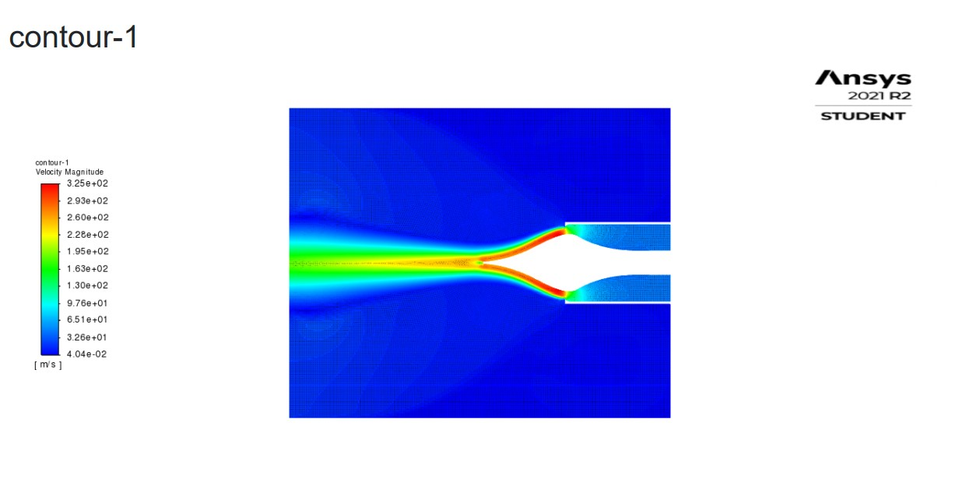

Figure 9: Velocity contour of exhaust gases in control volume

# CHAPTER 3: DESIGN OF NOZZLE

## 3.1 DESIGN OF BELL-SHAPED CD NOZZLE

A bell nozzle is a converging nozzle with a conical shaped extension. It is simple form of nozzle that converts pressure energy to kinetic energy of fluid. Figure 7 represents a bell nozzle used in rocket propulsion. In this project, a bell nozzle was initially designed before being re iterated to create an equivalent CD nozzle or an aerospike nozzle. The dimensions for bell nozzle were extracted using method of characteristics on MATLAB [8],[9].

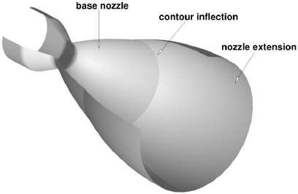

Source: [Research gate: Principle of dual gate nozzle](https://www.researchgate.net/figure/Principle-of-a-dual-bell-nozzle_fig1_278390724/download)

Figure 10: Schematic representation of a bell nozzle

## 3.2 DESIGN OF CONICAL SHAPED CD NOZZLE

A CD was designed taking bell nozzle as a reference. Taking the same value of throat area and exit area, an equivalent CD nozzle was re iterated where bell shaped contours were replaced with a conical shaped contour as shown in figure 8. Conic nozzles don't use a separate principle from bell nozzles – it is the same supersonic/compressible flow expansion and acceleration of gas, in which the cross-sectional area of a channel gradually and monotonically increases. In fact, any converging diverging duct will accelerate compressed gas to supersonic speed as long as there is enough chamber pressure relative to ambient pressure to make it get supersonic in the throat. Bell nozzles, however, must be carefully designed to tailor the expansion and make compression and expansion shock waves (created by the curvature) line up, and the parameters are more sensitive [7]. This was done taking the consideration of manufacturing facility available at Kathmandu University. Curved contours are difficult to manufacture using traditional machining techniques which is why a conical shape was improvised.

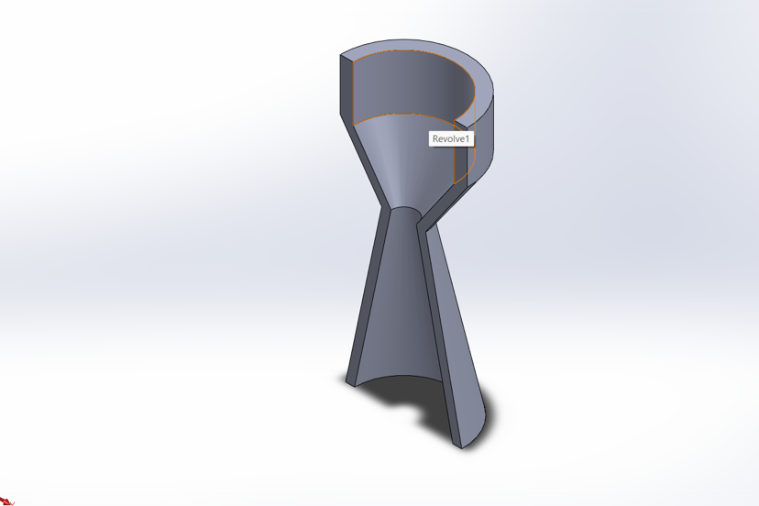

Figure : Schematic diagram of conical shaped CD nozzle created in SOLIDWORKS

## 3.3 DESIGN OF AN AEROSPIKE NOZZLE

The diameters and spike length were the important parameters to be determined. Getting values of these parameters would conclude the design of aerospike nozzle. While the nozzle area and inside pressure would remain same for any nozzle system, an equivalent derivative of a CD nozzle was to be obtained in order to ensure the same rate of momentum change for exhaust gases with minimum error. By considering nozzle area from previously designed CD nozzle, clearance distance between spike and cowl of the aerospike was determined. From further hit and trial simulation analysis in ANSYS, the length of spike was obtained on which thrust vectoring was minimum. Figure 14 is the final aerospike nozzle design opted out for manufacturing by taking reference of the dimensions of CD nozzle shown in figure 12.

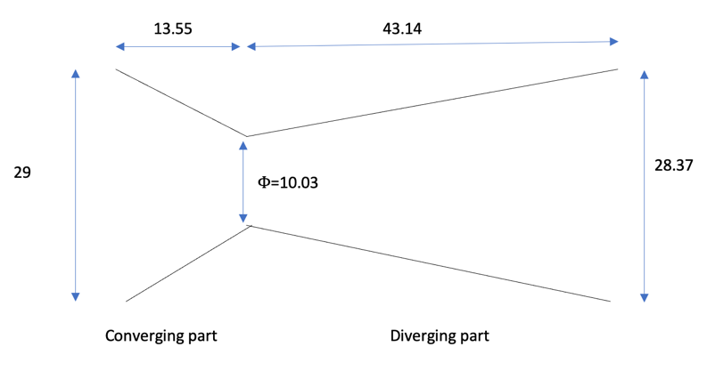

Figure : Dimensions for a converging-diverging nozzle

From equation (ii), thrust generated depends on

* Mass flow rate at exit
* Velocity of flow at exit
* Throat area

Throat area = = 78.97 mm2

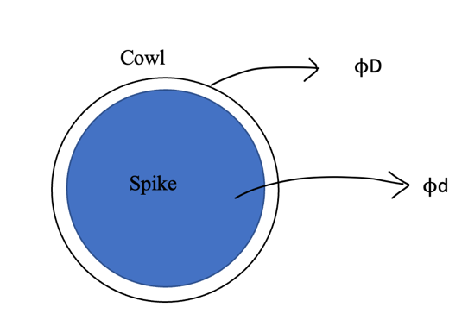Using obtained throat area to determine area between two concentric circles representing cowl and spike, let ‘D’ be diameter of cowl and ‘d’ be diameter of spike. The governing equation describing relation between two diameters is

d =

For D = 20mm, d = 17.30mm

D = 30mm, d = 28.27mm

D = 40mm, d = 38.72mm

Figure : Bottom view of an aerospike nozzle. Blue portion represents cross section of spike and white portion represents exit area

D = 50mm, d = 48.98mm

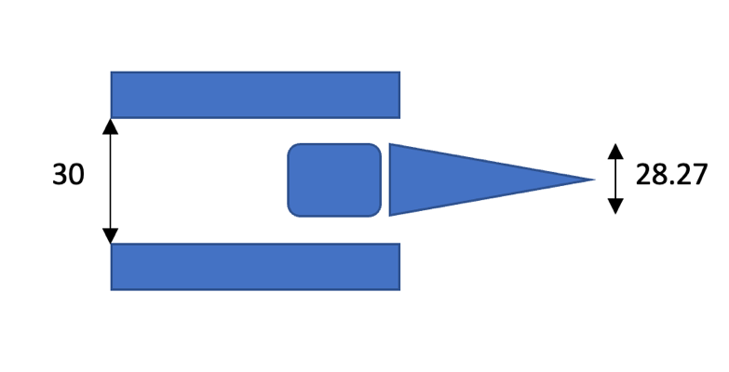

Figure :Representation of an aerospike nozzle

# CHAPTER 4: PROPULSION EXPERIMENTATION

## SOLID PROPELLANT

The propulsion experimentation is done to collect data on the thrust delivered by CD and aerospike nozzle under the atmospheric pressure. A small prototype of rocket propulsion system was fabricated for this sole purpose. But instead of using liquid propellant (generally hydrogen or methane in case of rocket launches), solid propellants were selected for this specific purpose. Solid fuels are highly dense and relatively safer and cheaper than liquid fuels. Solid propellants also require less complicated combustion chamber and doesn’t require an engine. A mixture of sugar and potassium nitrate is a good rocket fuel as it represents the reaction of solids (nitrate and sugar) to form gases (carbon dioxide and water) and dispense thrust by building pressure inside the pressure vessel. The chemical reaction is given below.

2 KNO3(s) + CH2O(s) → 2 KNO2(s) + CO2(g) + H2O(g)

## PRESSURE VESSEL / COMBUSTION CHMABER

Among solid propulsion system, combustion chamber also acts as a pressure vessel unlike that of liquid propulsion system. This makes the overall experimentation setup comparatively easier to build than of liquid propulsion system. The pressure vessel in this particular investigation is built from a 30mm mild steel hollow pipe.

## TEST RIG

A horizontal test stand was also fabricated as shown in figure 15 in order to house the nozzle and combustion chamber. All sensors and electronics are placed inside the test rig to collect data on necessary parameters related to thrust. The stand is oriented horizontally parallel to the ground and thus prevents any movement generated from the thrust of combustion.

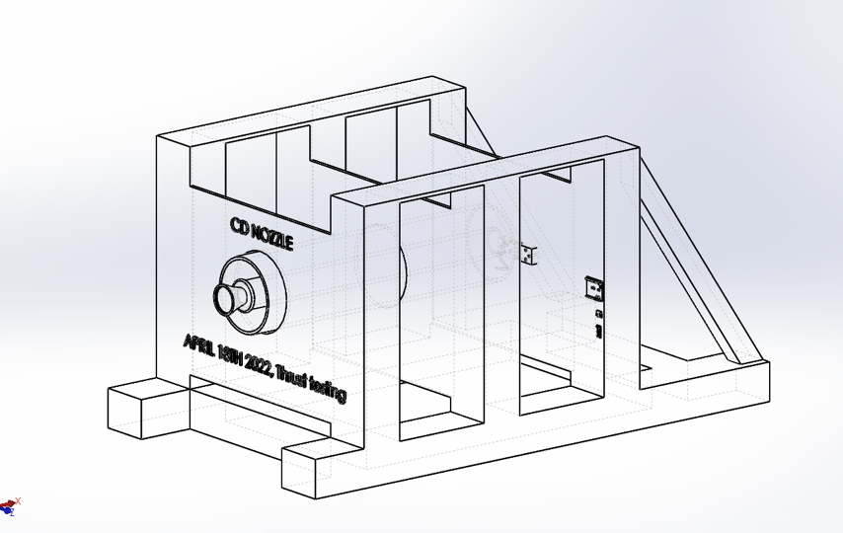

Figure : Test Rig that houses and immobilizes the nozzle. This drawing was made using SOLIDWORKS

## SENSORS AND ELECTRONICS

Some of the sensors and electronics used in this experimentation are i) *Load cell*, ii) Signal amplifier, iii) Uno, iv) Bluetooth receivers and dispatcher, v) Spark plug and vi) Arduino interface as shown in figure 16.

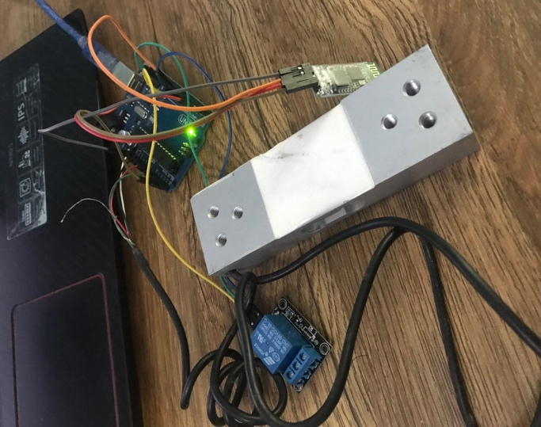

Figure : Sensors and necessary electronics used for experimentation

# CHAPTER 5: FUTURE OF THE PROJECT

## GANTT CHART FOR FIRST SEMESTER

As planned in the project proposal, our schedule had been followed accordingly. Following the Gannt chart we have completed this semester’s work which include literature review, calculations, CAD and CFD.

|  |  |  |  |  |
| --- | --- | --- | --- | --- |
| Date/Prescribed work | Fabrication | Electronics Assembly | Testing and Data collection | Documentation |
| May 1st week |  |  |  |  |
| May 2nd week |  |  |  |  |
| May 3rd week |  |  |  |  |
| May 4th week |  |  |  |  |
| June 1st week |  |  |  |  |
| June 2nd week |  |  |  |  |
| June 3rd week |  |  |  |  |
| June 4th week |  |  |  |  |

*Note: Highlighted sections indicate working weeks*

Table: Gant chart for upcoming working weeks

## 5.2 WORK UNEXPENDED

The project has come a long way since it was initiated in 2021, several portions such as literature review, nozzle design, thermal calculations and flow simulations have been accomplished. The design and fabrication of both CD and aerospike nozzles have demanded several iterations of study as well as procedures. While most of the time has been committed towards manufacturing the nozzles under uneasy circumstances, this project has been an interesting experience among the authors. The fabrication of CD nozzle has been successfully delivered by this date, but several more design iterations are required for production of aerospike nozzle. The test will finally begin after individually manufacturing few more spare nozzles. The sole purpose of this test is to collect data on the thrust delivered and to back up the claims made from flow simulation performed under the controlled domain. The project will be wrapped up after completion of documentation on obtained results.

# CHAPTER 4: CONCLUSION

Aerospike nozzle is a preferable alternative nozzle system being considered for its prominent features and altitude compensating features. This report sums up all the progress the team has accumulated over the period of a year. Theoretical framework has been laid down and required mathematical modelling for heat flow, design and flow simulations have been done for the aerospike nozzle. The temperature distribution on the cowl assuming 10 nodes has the highest temperature of 1200 degree Celsius and coolest being 1050 degrees Celsius. After performing several design iterations, a scaled down prototype of CD nozzle was manufactured using lathe.

# GLOSSARY

* *Altitude Compensation:* Ability of Aerospike nozzle to maintain a certain range of efficiency over different altitudes
* *Choke Flow:* A condition when mass flow rate per unit area does not increase even though other affecting factors are optimized
* *Flow Separation:* Separation of exhaust from any surface
* *Wet Mass:* Total initial mass of rocket including propellant
* *Over Expansion:* Positive sideways vector component on the exhaust gas after separation
* *Under Expansion:* Negative sideways vector component on the exhaust gas after separation
* *Mach Number:* Ratio of velocity of exhaust to velocity of sound
* *Back Pressure:* Pressure at exit
* *Load Cell:* A sensor that measures force and converts into digital signal

# REFERENCES

1. RUBY CALZADA, NASA official website, “*Lockheed X-33”*, 2004
2. G. SUSHEEL NARAYAN, VIKKY CHOBEY, P. MANI KIRAN, MIHIR BARANWAL

*“A Research Paper on Analysis of De-Laval nozzle on Ansys Workbench”,* International Research Journal of Engineering and Technology (IRJET), 2019

1. CHOUDHURI, A. R. (1998). “*The Physics of Fluids and Plasmas: An Introduction for*

*Astrophysicists”*

1. NANCY HALL, NASA official website, GLEM Research Center “*General Thrust Equations” 2021*
2. NAVEEN KUMAR K GOPALSAMY M, DANIAL ANTONY (2008). “*Design and optimization of Aerospike nozzle using CFD*”
3. HUBNER, DEWHIRST, SMITH, BYRON, “*The Finite Element Method for Engineers”,* John Wiley and Sons Inc. U.K, 2013
4. STACKEXCHANGE online blog

Link: https://space.stackexchange.com/questions/44549/do-converging-diverging-engine-nozzles-need-to-be-bell-shape

1. MATT VERNACCHIA, “*Spike Contour Algorithm”*, Pyralis Rocket Engine, [2013]
2. MURROUGH MURNAGHAN, “*Study of minimum length, supersonic* *Nozzle design using the Method of Characteristics”,* Thesis on Master’s Degree in Space and Aeronautical Engineering (MASE), UNIVERSITAT POLIT`ECNICA DE CATALUNYA [2019]